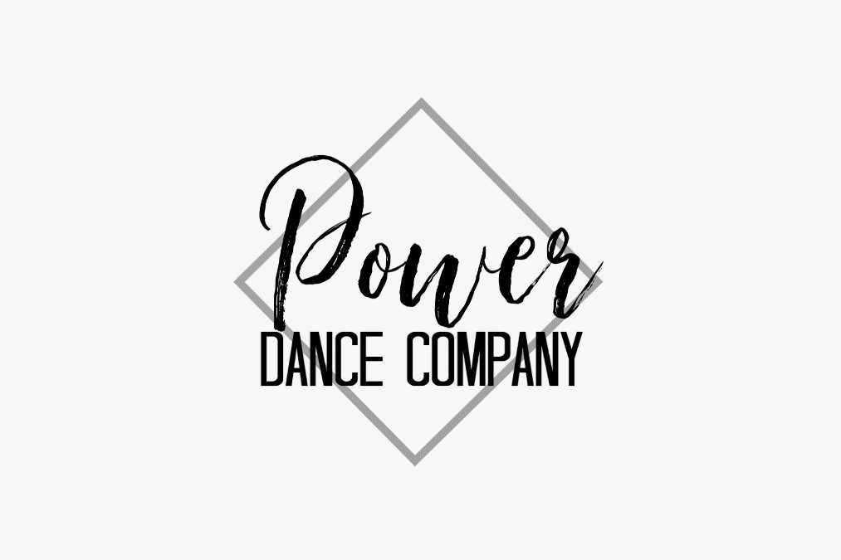

2020-2021
Studio Policy
HANDBOOK

Welcome to our Studio
Here at Power Dance Company we are committed to providing a space for students to feel confident, safe, and loved, while receiving a solid dance education. After 20 years of dance training and 11 years teaching experience, we are continuing our dance and acro education to provide students with the safest and best training techniques.
Tuition & Payments
Tiny Tots & Minis
30 Minute Class - $35 a month
45 Minute Class - $45 a month
Each additional class - $20 a month
Petites & Juniors
45 Minutes-1 Hour Class - $50 a month
Each additional class - $20 a month
All tuition/fees/payments are nonrefundable. Tuition is due one month in advance through auto draft. Students with accounts that are not current will not be able to participate in class. More info on this in your enrollment agreement. Or ask the front desk.
Solos & Private Lessons
30 minutes-$25 per session
60 minute-$50 per session
Fees are due before classes begin. They can be arranged monthly.
Dress Code
All genres must have appropriate shoes and attire. Our staff can help you with shoe and clothing selection. Dance shoes and attire can be ordered through the studio. See our staff to get sized.
Ballet – Pink Leather Ballet slippers and fitted dance attire
Jazz, Lyrical, and Pom - Nude jazz boot and fitted dance attire
Tap – Tap shoes and fitted dance attire
Hip Hop - Jazz or tennis shoes and comfortable clothes (black tennis shoes preferred)
Acro Tumbling – Barefoot and fitted attire
Leotards, dance shorts, skirts, sports bras, or anything the dancer is comfortable is appropriate. Hair must be secured out of face.
Competitive
Our competitive program is all about the dancer’s experience. Dancers are required to take their age appropriate ballet combo class plus their company or solo classes. Acro is encouraged. Additional fees will include costumes for competitive dance, competition entry fees, and music edits.
Christmas Showcase
Our Christmas Showcase is a fun opportunity for students to show parents progress and celebrate the most wonderful time of year! This show is more laid back than our Spring Recital, but it is still a fabulous production full of dazzle. Costumes are not required for this show, but we will have a dress code and mandatory studio Christmas shirts.
Spring Recital
Our Spring Recital is a fun and exciting time for dancers! Most combo classes will perform two dances. Pom/cheer combo class will perform one upbeat pom routine. Each dance will require a costume. Recital will be held at the end of May-beginning of June. Spring Recital costume payments are due November 1st in full. Monthly payments can be made the 15th of every month September-February by postdated check or automatic charge.
Costume payments are nonrefundable. More info can be found in your enrollment release.
Studio Closings
Our studio follows closely to the Public-School calendar of the town the studio resides in. We will be closed the following.
September 3 Labor Day
October 14-18 Fall Break
November 25-29 Thanksgiving Break
December 23-31 Christmas Break
January 1-3 New Year’s Eve Break
February 17 Studio Closed
March 16-20 Spring Break
With the addition of weather closing from time to time.
Tuition rates account for these days out of studio.
Studio policies
All classes are closed to viewers.
Late fees will be enforced.
No bullying from parents or students. Our studio is a place for students to feel safe.
Dress codes will be enforced.
Be mindful of other classes in session when arriving. Do not interrupt class.
It is the parent’s responsibility to stay informed.
Stay informed and be social!
Stay up to date with dance info via Facebook and Instagram.
Your parent portal is full of useful info so know your log-in.
How do we contact you?
Our primary source of communication is via email. Make sure your email in your parent portal is correct!
Best ways to contact the studio?
Email: powerdanceok@gmail.com
Phone: 405-430-9689
Facebook messenger of appropriate studio.

Facebook.com/powerdanceok
Facebook.com/powerdanceweatherford
Instagram.com/power_dance_co

